**Дата**: 16.05.2025

**Клас**: 3-АБ

**Предмет**: англійська мова

**Тема:** Контроль навичок письма.

**Мета:** : формувати навички вживання лексичних одиниць по темі; удосконалювати навички читання, аудіювання й усного монологічного мовлення; розвивати пізнавальні інтереси учнів; виховувати інтерес до самостійного пошуку потрібної інформації, а також загальну культуру учнів.

**Вчитель**: Руда Д.В.

Хід уроку

1.Greeting

Good afternoon, guys! I’m glad to see you. Are you ready to start our lesson? All set?

2. Wаrm up / Listening

Уважно слухати аудіо трек і дати відповідь на питання вчителя <https://www.youtube.com/watch?v=Zvp8_fT5mJQ> .

3. Speaking

What day is tomorrow?

What day is the day after tomorrow?

What day was it yesterday?

What day was the day before yesterday?

Which days of the week do you have an English class?

What is your last working day of the week?

What is your first working day of the week?

On which day do you start work again?

What day of the week is the hardest for you to spell?

What days of the week are the weekend?

What is the date today?

What was the date yesterday?

What will the date be tomorrow?

4. Повторення

**Irregular Verbs**

To see- saw-seen- бачити

To sell- sold-sold- (продавати)

To do-did-done(робити)

To come- came-come(приходити)

To go-went-gone(йти)

To tell-told-told(розповідати)

To find-found-found(знаходити)

To give-gave-given(давати)

To sleep – slept – slept (спати)

To write-wrote-written- писати

To steal-stole-stolen- вкрасти

To speak-spoke-spoken-говорити (володіти мовою)

5. Writing

Контроль навичок письма.

**Form 3 Term 2 Test Unit 7 ‘’Nature and animals’’**

1. **Read. Guess the animal. Complete.**

1. It is green. It can swim. It likes to eat meat. A. 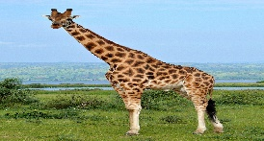

It has got a big mouth. It lives in the water.

2. It is big. It is brown. It has got a mane and paws. B. 

It can run very fast. It likes to eat meat. It has got fur.

3. It is black and white. It lives on the farm. C. 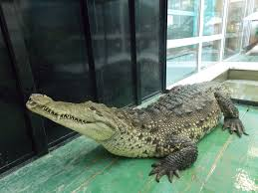

It gives us milk. It likes to eat grass.

4. It is very tall. It is brown. It has got a very long neck. D. 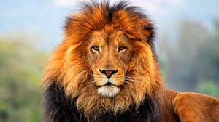

It has got four long legs. It likes to eat leaves.

5. It is black or brown. It has got long arms, short legs E. 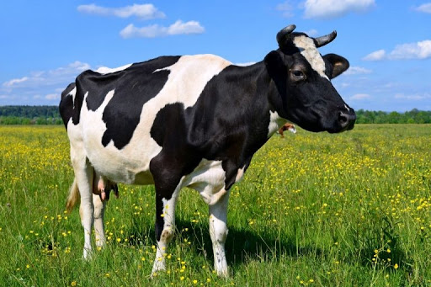

and do not have tails. Little babies ride ‘’piggybacks’’.

It likes to eat fruits, leaves and insects.

6. It is little. It can fly and sing. It lives on the trees. F. 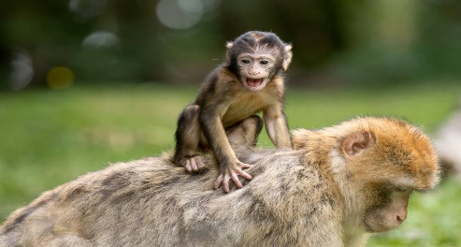

It has got feathers.

**II. Read. Write TRUE or FALSE:**

1. Cows can slide. ______ 2. Cats can bark. ___________

3. Tigers can fly. ______ 4. Dogs can bark. ___________

5. Snakes can slide.______ 6. Crocodiles can swim. ___________

**III. Grammar. Write in the plural:**

1.one dog - four ____________ 2. One sheep – five ______________

3. one calf – two ___________ 4. One mouse – ten ______________

5. one goose – three _____________ 6. One fly – seven ___________

**IV. Writing. Describe your favourite animal.**

My favourite animal is________________________.

It is _______________________________________.

It has got __________________________________.

It can _____________________________________.

It can’t ____________________________________.

6. Vocabulary

To observe – спостерігати (обзьов)

To close- закрити(клоуз)

to decide- вирішувати (дісайд)

to kiss- поцілувати(кіс)

to agree- погодитися(егрі)

7. Homework

1. Виконати письмово вправу 2 на past simple.

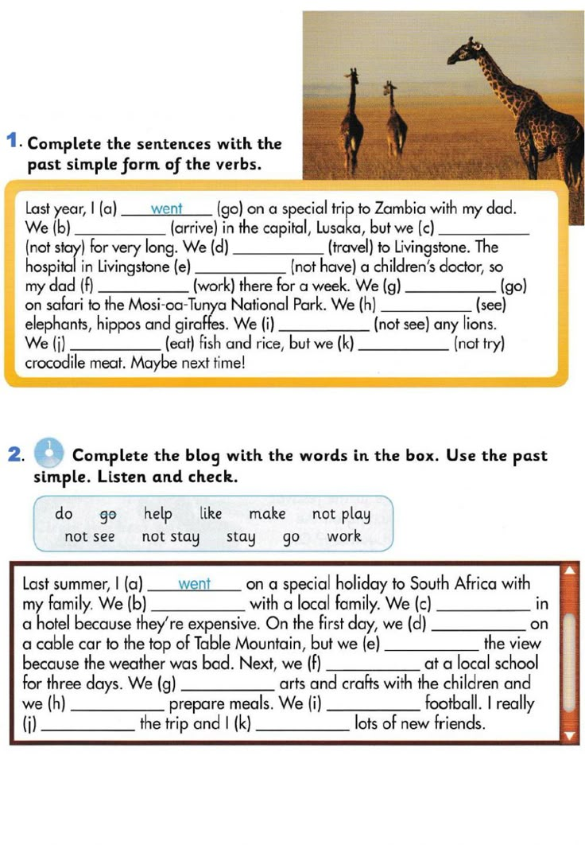

2. Вивчити неправильні дієслова в конспекті.